MTH401-Diffeerential Equations
Fall 2011 FINAL Paper 23 FEB, 2011
BY
*~*SHINING STAR*~*($$)

Q1.Write down the system of differential equations
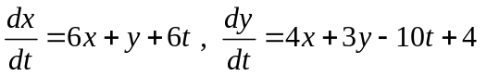
in form of 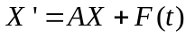

Solution:
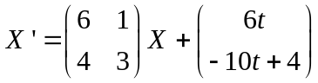

Q2. Solve the system of differential equations 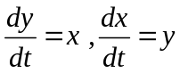by systematic elimination.

Solution:
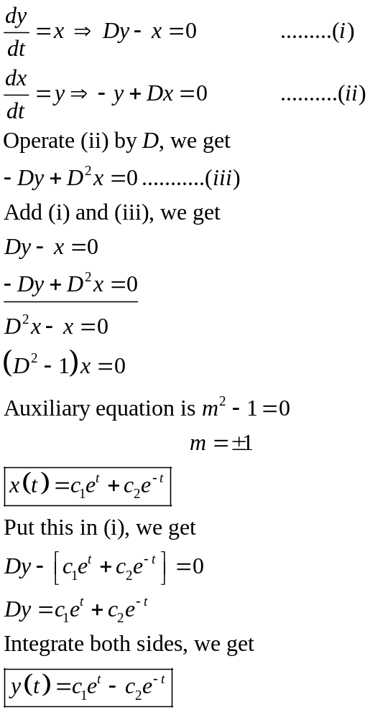
Q3. Find a series solution for the differential equation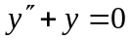 about 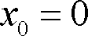 such that
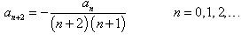and 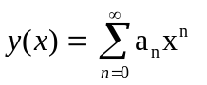

Solution:

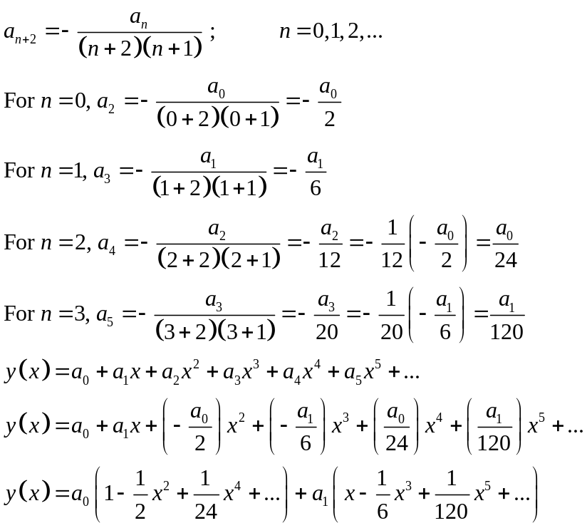

Q4. Write solution 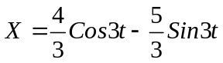in the form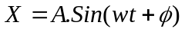.

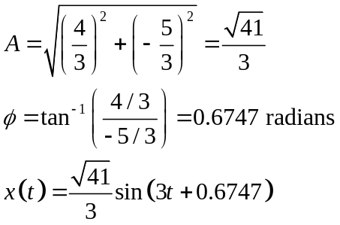
Q5. 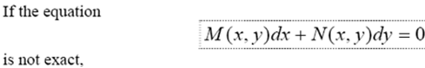
Case 1:
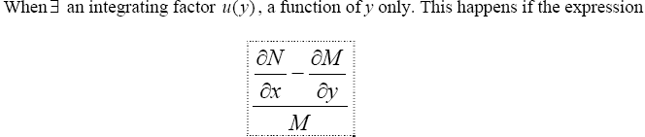
is a function of y
Case2:
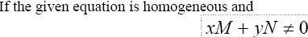
Then find the integrating factor in both cases.

Solution:

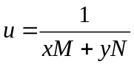
Q6. Find eigen vector of

A=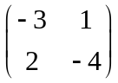,corresponding eigen value 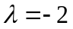.

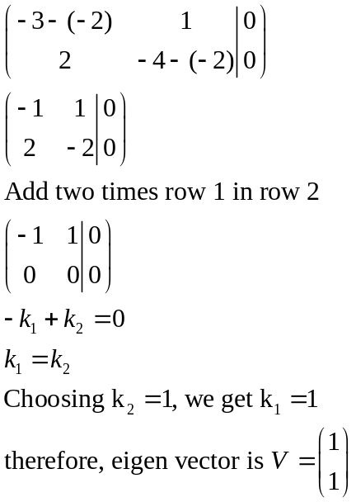

Q8. Under which conditions linear independence of the solutions for the differential equation is guaranteed?
Solution:

Linear independence is guaranteed in case when the Wronskian of the two solutions is not equal to zero.
Q9. Write the homogenous system of differential equations
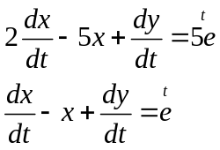lec 36 example 1
in decoupled form.

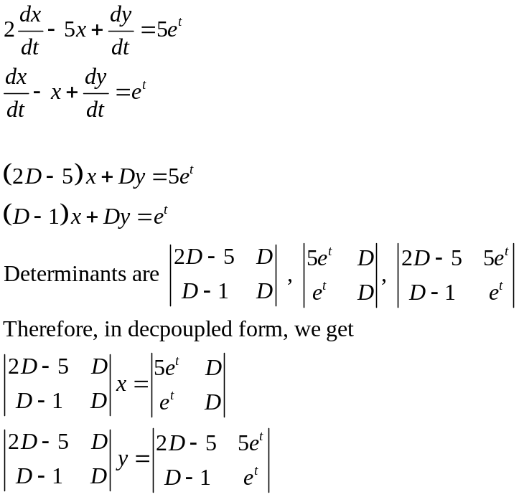

Q10. When Frobenius’ Theorem is used in Differential Equation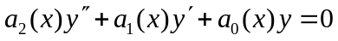?

Solution:
When we have a regular singular point x= x0, then we can find at least one series solution of the form 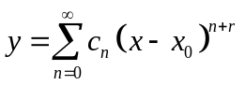, where r is the constant that we will determine after solving the differential equation.
Q11. Find the eigenvalues of the following system
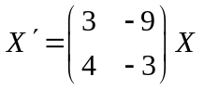

Solution:
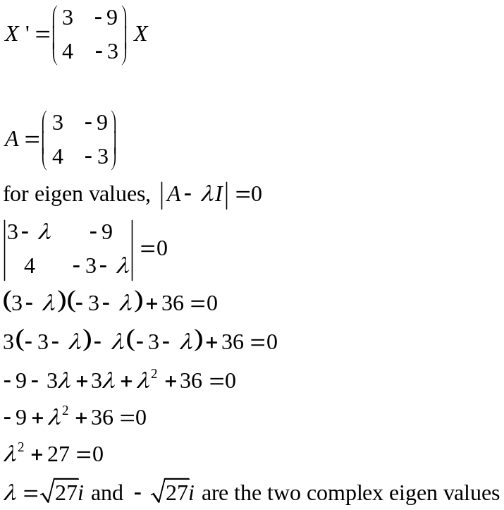

Q12. Define Legendre’s polynomial of degree n
Solution:
Legendre polynomial is an n^{th} degree polynomial and it is given by the formula 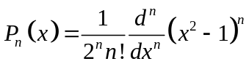
Q13. What is the ordinary differential equation and give an example?
Solution:
A differential equation which only includes ordinary derivatives is known as ordinary differential equation. Some examples of ordinary differential equations include:
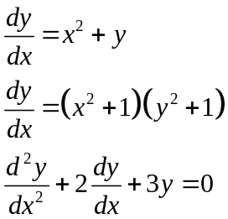

sum tht is remembrd m sharing here.
a)matrix A nd value of lembda was given to find the eigen vector? 3 marks.
b)X'=AX was given to find the eigenvalue and eigen vector? 5 marks.
c)solve DE dy-7dx=0 for initial value f(0)=1? 5 marks.
d)find the general solution of 4x^2 y '' + 4xy' (4x^2-25)y=0 (it is the Bessel's Equation. nd same question is given in exercise pg 314 of our handouts)? 5 marks
e)when a function is said to be analytic at any point? 2 marks
f) what is the ratio test? (its on pg 264 of our handouts) 5 marks
g) what is the formula for radius of convergence? (its on pg 265 of our hndouts)2 marks
h)write system of linear differential equations for two variables x and y? (its on pg 333 of our handouts).2 marks
i) write any 3 D.Es of order 2? 3 marks
j) D.E was given to convert in normal form? 3 marks
k) any example of boundary value problem? 2 marks
power series sy ziada nhi tha. lectre 35 to 45 pr ziada emphsis tha

Q No.2 ------------------5 marks:
Write annihilator operator for x+3xe^(6x) e ki power 6x
Q No.3 ------------------3 marks:
Write the solution of simple harmonic motion in alternative simpler form
x(t)=c1coswt+c2sinwt from lec 22 page 199
Q No.4 ------------------2 marks:
Define general linear DE of nth orde
technical MCQs mostly based on solving 1,2 steps short questions
example 9 page 358 2
define elementary row operation 2 P# 360
Rij , cRi , cRi+Rj 3 pages 362
eigenvalue of multiplicity m 3
fundamental of matrix 3
page 406, EX- 3rd question 5
Bessel equation 5
no more remembered (questions

must do general solution , with bessel equation. 5marks
objective from matrices 10-15 marks
what is determine? how to find it.
The determinant see on page 364

total 39 question
Objective mostly from Matrix......
Write equation in matrix form...
find Eigen vectors and Eigen values.
Find general solution........ 5marks..
Forbenius Theorem......... 5marks

mara aaj 16 jul ko math401 ka paper tha . Us mai zayada tar question eigenvalues ke aaye the aur sath mai ek eigenvectors ka bhe question tha. Bessel equation ka bhe ek question tha. Zayada tar paper lec num 30 to 45 se aaya tha. Aur kush MCQ past papers mai se aaye the lakin agar achi tarai ho aur concept clear ho to zayada tak MCQ 's kafi asan the.

24 jluy
Bessels equation question was similar to example 1 page 309
explain convergence and infinty condition of a infintye sereies.page 263
write in matrix form similar to example on page 432
why we use c not equal to zero in forbineous method
super position method for vectors
harmonic motion example similar on page 213 5 marks
paper was easy
best of luck to all of you too

